1528. Shuffle String

Easy
2.5K
456

Companies
You are given a string s and an integer array indices of the same length. The string s will be shuffled such that the character at the ith position moves to indices[i] in the shuffled string.
Return the shuffled string.

Example 1:
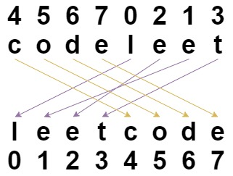
Input: s = "codeleet", indices = [4,5,6,7,0,2,1,3]
Output: "leetcode"
Explanation: As shown, "codeleet" becomes "leetcode" after shuffling.
Example 2:
Input: s = "abc", indices = [0,1,2]
Output: "abc"
Explanation: After shuffling, each character remains in its position.

Constraints:
- s.length == indices.length == n
- 1 <= n <= 100
- s consists of only lowercase English letters.
- 0 <= indices[i] < n
- All values of indices are unique.

